1. IMDB schema

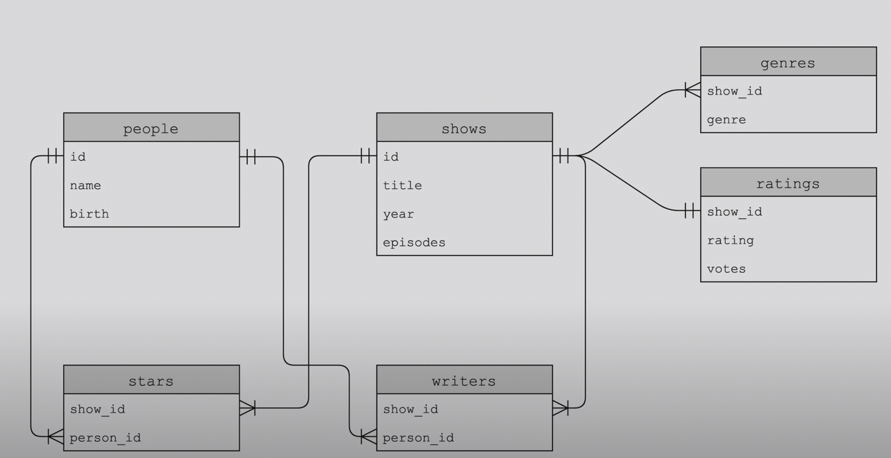

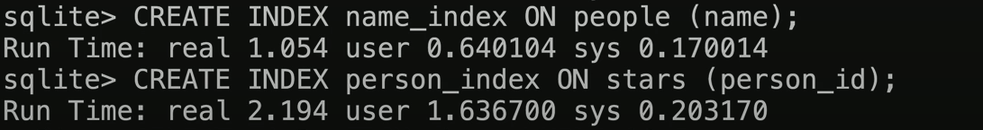

1. Sdf
2. sdf